**Installation Procedure**

* System Requirements :

PhP 5.3.5, Apache 2.2.17

* Download Community Edition Zip file. Unzip it in www folder in your apache server.

Two folders are available namely

1. install 2) web_school

Run the ‘install’ folder on your browser.

* Steps for installation:

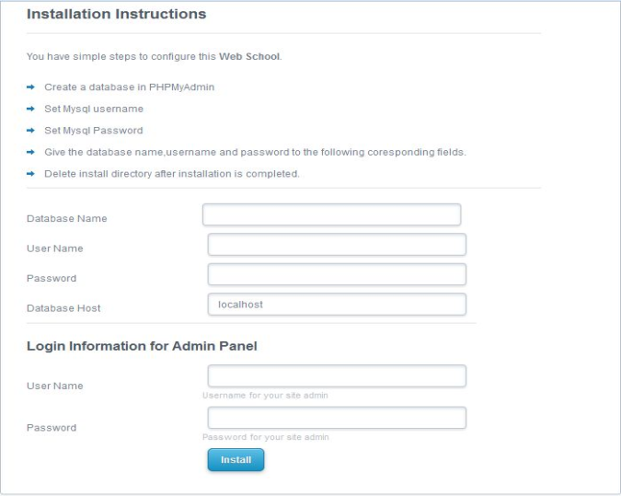

* Set database name.
* Provide username and password of PhpMyadmin database.

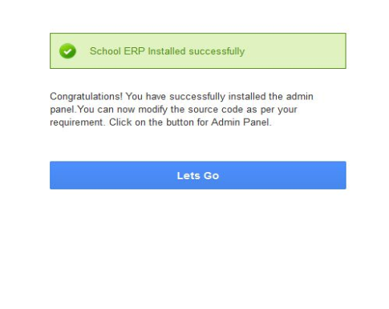

* Set username and password for your admin panel.
* The above appearance ensures you have successfully installed the application.
* Now you are ready to login by clicking on “Lets go”.

Note : Following trouble shooting steps may be helpful in case of Login,Logout,Icon disappearance or similar errors:

Now you have to set the path name for webschool. Open web_school folder→ inc folder→ functions.php file.

Edit the following marked in **red,** if the path is different from the one mentioned below:

Line2 →define("SITE_URL","<http://localhost/communityedition/web_school/>");

Line3 → define("VIEW_SITE_URL","<http://localhost/communityedition/web_school/view/>");